**Brain Tumor Classification using CNN and Transformers**

**Class: Computer Vision CSC 752 -U18**

**Department of Computer Science**

**University of South Dakota**

**Group members:**

**Neerajdattu Dudam**

**Nagamani Motupalli**

**Madhu Sree Sane**

**Mounika Bollina**

**Supervisor: Dr. Lina Chato**

**Fall 2024**

1. **Objective**

The primary objective of this project is to develop a robust and accurate system for classifying brain tumors using advanced machine learning and computer vision techniques. Specifically, we aim to:

* Utilize Convolutional Neural Networks (CNNs) to classify brain tumors based on a provided dataset.
* Experiment with various network architectures and layers to optimize classification performance.
* Benchmark our custom CNN models against state-of-the art models such as ResNet50.
* Explore the use of transformers, including Swin Transformer and Vision Transformer, to enhance model performance.
* Implement transfer learning to leverage pre-trained models and improve classification accuracy and efficiency.
* Conduct a comprehensive evaluation of each method’s strengths and limitations to identify the most effective approach for brain tumor classification.

1. **Data**

The dataset used in this project will consist of medical imaging data, specifically MRI scans of brain tumors. The dataset will include:

* High-resolution images of brain tumors, labeled with the type of tumor, there are four classes that have been labeled in the dataset.
* Pre-processed images to ensure consistency and quality for training and testing the models.
* A split of the dataset into training, and test sets to evaluate model performance accurately.

1. **Hypothesis**

Our hypothesis is that advanced machine learning models, particularly CNNs and transformers, can significantly improve the accuracy of brain tumor classification. We believe that:

* Custom CNN models, when optimized with various architectures and layers, will achieve high classification accuracy.
* State-of-the-art models like ResNet50 will provide a strong benchmark for comparison.
* Transformers, such as Swin Transformer and Vision Transformer, will offer enhanced performance due to their ability to capture complex patterns in the imaging data.
* Transfer learning will further improve classification ac curacy by leveraging the knowledge from pre-trained models on large datasets.
* A combination of these techniques will result in a highly effective and efficient system for brain tumor classification.

**4. Expectations**

We expect the following outcomes from our project:

* Development of a high-performing CNN model tailored for brain tumor classification.
* Identification of the optimal network architecture and layer configuration for our custom models.
* Comprehensive performance comparison between our custom models and state-of-the-art models like ResNet50.
* Demonstration of the effectiveness of transformers in enhancing classification performance.
* Successful implementation of transfer learning, leading to improved accuracy and efficiency.
* Detailed analysis of each method’s strengths and limitations, providing valuable insights for future research and development in medical imaging and diagnostics.

By achieving these outcomes, we aim to contribute to the advancement of medical imaging technologies and provide a reliable tool for the early detection and classification of brain tumors, ultimately improving patient outcomes and treatment strategies.

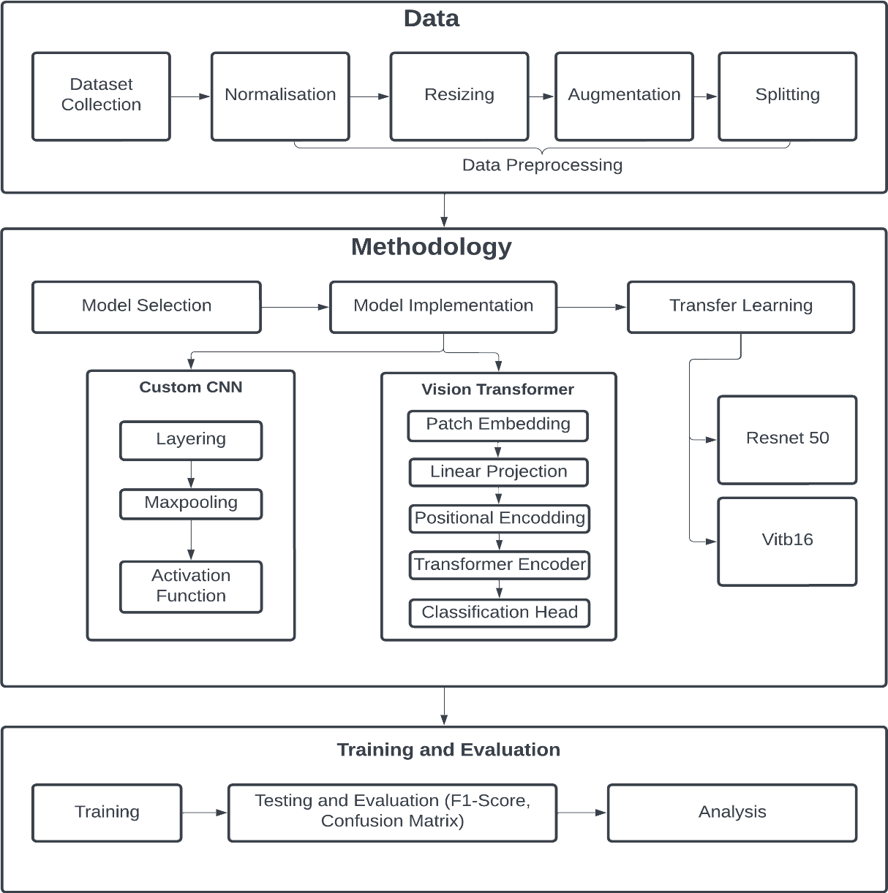**5. Project Process and Design**

**References**

[1] Sharma, N., Jain, V., Mishra, A. (2018). An analysis of convolutional neural networks for image classification. Procedia Computer Science, 132, 377–384. https://doi.org/10.1016/j.procs.2018.05.198

[2] M. Nickparvar. ”Brain tumor MRI dataset,” in Kaggle, 2021.

[3] PyTorch, ”ViT-B/16: Vision Transformer with BERT-style tokens,” Py Torch torchvision Library.

[4] J. Cheng, ”Brain tumor dataset,” 2017.

[5] J. Sarta, ”Brain tumor classification (MRI),” in Kaggle, 2020.

[6] A. Hamada, ”Br35H:: Brain tumor detection 2021,” in Kaggle, 2020.

[7] R. Samy, ”Brain tumor using CNN,” in Kaggle, 2024.

[8] K. Tian, ”Brain tumor type classification- VGG-19,” in Kaggle, 2024.

[9] A. Dosovitskiy et al., “AN IMAGE IS WORTH 16X16 WORDS: TRANSFORMERS FOR IMAGE RECOGNITION AT SCALE,” in ICLR 2021- 9th International Conference on Learning Representations, 2021.

[10] Lorente, ` O., Riera, I., Rana, A. (2021, May 11). Image Clas sification with Classic and Deep Learning Techniques. arXiv.org. https://arxiv.org/abs/2105.04895